**A project report on**

**“Online Course Platform database project”**

**submitted by: -**

**Ch. Vamsi vishnu vardhan**

STUDENT ID: - AF0401782

Batch code: -ANP-C7971

Lecturer: - “CHAITHANYA POIGHAL”

INSTITUTE: - “ANUDIP FOUNDATION”



**Abstract :-**

**This project report delves into the design and implementation of a database for an online course platform. The introduction outlines the need for a robust and scalable database to manage user data, course content, and interactions efficiently. The E-R diagram illustrates the relationships between entities such as users, courses, and enrolments, providing a clear blueprint for the database structure. The objectives include ensuring data integrity, facilitating easy access to information, and supporting various user roles. The conclusion highlights the successful creation of a functional database that meets the platform’s requirements and suggests future enhancements for improved performance and scalability.**

* **Project Overview:**

**The project focuses on designing and implementing a database for an online course platform to manage user data, course content, and interactions efficiently.**

**Introduction: Highlights the need for a robust and scalable database to support the growing demand for online education and ensure seamless user experience.**

**E-R Diagram: Illustrates the relationships between key entities such as users, courses, enrolments, instructors, and assessments, providing a clear blueprint for the database structure.**

**Objectives:**

* + **Ensure data integrity and consistency.**
  + **Facilitate easy access to information for different user roles (students, instructors, administrators).**
  + **Support efficient data management and retrieval.**
  + **Implement security measures to protect sensitive information.**

**System Design:**

* + **Utilizes normalization techniques to eliminate data redundancy.**
  + **Implements advanced indexing strategies to enhance data retrieval speeds.**
  + **Incorporates security measures to safeguard user credentials and payment details.**

Online Course Platform: A Comprehensive Database Design

This project aims to develop a robust and scalable database design for an online course platform. The platform will provide users with a centralized hub to access a variety of educational courses, interact with instructors and peers, and track their learning progress. The database design will serve as the foundation for the platform's functionality, ensuring efficient data storage, retrieval, and management. By carefully considering the entities, attributes, and relationships involved in the online course platform, this project will create a solid database structure that supports the platform's core features and future growth.

**Entities for the Online Course Platform**

* Users: Represents individuals who interact with the platform (students, instructors, administrators).
* Courses: Contains information about the courses offered on the platform (title, description, instructor, category, price, etc.).
* Lessons: Represents individual units of content within a course (title, content, order).
* Enrolments: Tracks which users are enrolled in which courses.
* Quizzes: Contains information about quizzes associated with courses.
* Quiz Questions: Represents individual questions within a quiz.
* Quiz Submissions: Records user submissions for quizzes.

**Introduction to the E-R Model for the Online Course Platform:-**

* The Entity-Relationship (E-R) model is a graphical tool used to represent the conceptual design of a database. It provides a visual representation of the entities (data objects) and their relationships within a database system. By understanding the E-R model, we can effectively design the database for the online course platform, ensuring that it accurately captures the essential data elements and their interconnections. The E-R model helps in identifying entities, attributes, and relationships, which are crucial for building a well-structured and efficient database.

**Entity-Relationships for the Online Course Platform:-**

The Entity-Relationship (ER) model for the online course platform visually represents the entities (data objects) and their relationships within the database system. This model provides a clear understanding of how data is organized and interconnected.

**Key relationships:**

* Users and Courses: A many-to-many relationship exists between users and courses. This allows multiple users to enrol in a single course, and a single user can enrol in multiple courses.
* Courses and Lessons: A one-to-many relationship exists between courses and lessons. A course can have many lessons, but a lesson belongs to only one course.
* Courses and Quizzes: A one-to-many relationship exists between courses and quizzes. A course can have many quizzes, but a quiz belongs to only one course.
* Quizzes and Quiz Questions: A one-to-many relationship exists between quizzes and quiz questions. A quiz can have many questions, but a question belongs to only one quiz.
* Users and Quiz Submissions: A one-to-many relationship exists between users and quiz submissions. A user can submit many quizzes, but a submission belongs to only one user.
* Courses and Comments: A one-to-many relationship exists between courses and comments. A course can have many comments, but a comment belongs to only one course.
* Courses and Ratings: A one-to-many relationship exists between courses and ratings. A course can have many ratings, but a rating belongs to only one course.
* Users and Messages: A many-to-many relationship exists between users and messages. Multiple users can send or receive messages to/from one user, and a single user can send or receive messages to from multiple users.

Entities and Attributes for the Online Course Platform include the below:

Users

* user_id (primary key)
* username
* email
* password
* role (student, instructor, administrator)
* profile_picture (optional)

Courses

* course_id (primary key)
* title
* description
* instructor_id (foreign key to Users)
* category (foreign key to Categories)
* price (optional)
* enrollment_count

Lessons

* lesson_id (primary key)
* course_id (foreign key to Courses)
* title
* content (text, video, etc.)
* order

Enrollments

* enrollment_id (primary key)
* user_id (foreign key to Users)
* course_id (foreign key to Courses)
* enrollment_date

Quizzes

* quiz_id (primary key)
* course_id (foreign key to Courses)
* title
* due_date

Quiz Questions

* question_id (primary key)
* quiz_id (foreign key to Quizzes)
* question_text
* answer_options
* correct_answer

Quiz Submissions

* submission_id (primary key)
* user_id (foreign key to Users)
* quiz_id (foreign key to Quizzes)
* score

Categories

* category_id (primary key)
* name

Comments

* comment_id (primary key)
* user_id (foreign key to Users)
* course_id (foreign key to Courses)
* comment_text
* created_at

Certificates

* certificate_id (primary key)
* user_id (foreign key to Users)
* course_id (foreign key to Courses)
* issue_date

Payments

* payment_id (primary key)
* user_id (foreign key to Users)
* course_id (foreign key to Courses)
* amount
* payment_date
* payment_status

Announcements

* announcement_id (primary key)
* title
* content
* created_at

Messages

* message_id (primary key)
* sender_id (foreign key to Users)
* recipient_id (foreign key to Users)
* content
* created_at

Ratings

* rating_id (primary key)
* user_id (foreign key to Users)
* course_id (foreign key to Courses)
* rating (1-5 stars)
* created_at

**ENTITY RELATIONSHIP DIAGRAM-**

**Online course platform:-**

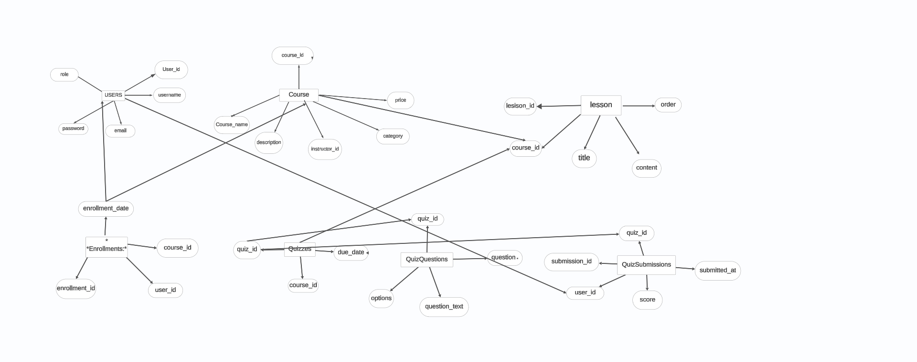

ERR

Diagram

Representation

-------------------

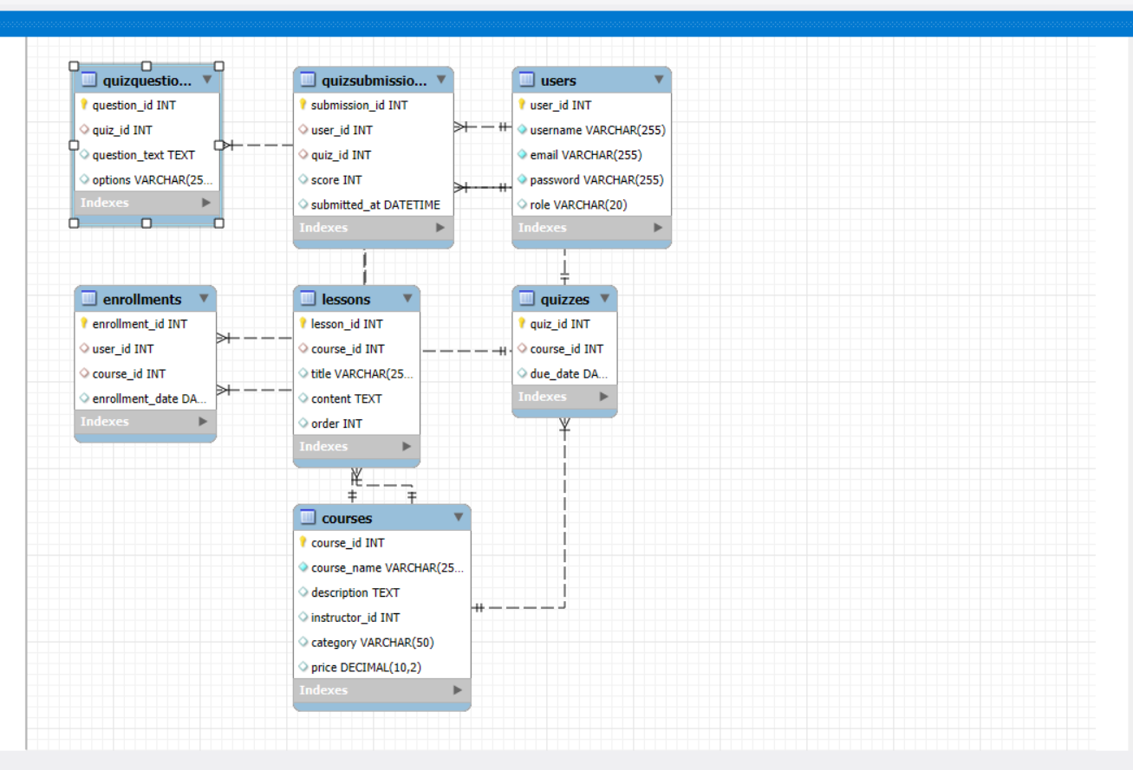

*Objectives of the Project:-*

The objectives of an online course platform database design project typically include:

1. Effective Course Management:

* Centralized Course Information: Store and manage all course-related data, including titles, descriptions, prerequisites, and learning outcomes.
* Instructor and Student Management: Maintain records of instructors and students enrolled in each course.
* Course Enrolment and Tracking: Handle course enrolment processes and track student progress.

2. Efficient Content Delivery:

* Course Material Storage: Store and organize course materials, such as lectures, assignments, quizzes, and readings.
* Content Access Control: Implement mechanisms to control access to course materials based on student enrolment and permissions.
* Version Control: Manage multiple versions of course materials and track changes.

3. Robust Learning Management:

* Assignment Submission and Grading: Facilitate assignment submission and grading processes.
* Quizzes and Assessments: Create and administer quizzes and assessments.
* Progress Tracking: Monitor student progress and provide feedback.

4. Interactive Communication:

* Discussion Forums: Create and manage discussion forums for student interaction and collaboration.
* Messaging and Notifications: Enable messaging between instructors and students, as well as sending notifications about important updates.

5. Data Analytics and Reporting:

* Performance Tracking: Gather data on student performance and course completion rates.
* Usage Analytics: Analyze platform usage patterns to identify areas for improvement.
* Reporting Capabilities: Generate reports on various aspects of the platform, such as course enrollment, student engagement, and instructor activity.

6. Scalability and Performance:

* Scalable Architecture: Design a database that can handle increasing numbers of users and courses.
* Performance Optimization: Implement techniques to ensure efficient data retrieval and processing.

7. Security and Privacy:

* Data Protection: Protect sensitive student and instructor data from unauthorized access.
* Compliance: Adhere to relevant data privacy regulations (e.g., GDPR, FERPA).

8. User-Friendly Interface:

* Intuitive Design: Create a user-friendly interface that is easy for instructors and students to navigate.
* Accessibility: Ensure the platform is accessible to users with disabilities.

By achieving these objectives, an online course platform database design can provide a solid foundation for a successful and effective learning environment.

System Requirements for Online Course Platform Database Design:

* Hardware: Powerful server, database server, network infrastructure.
* Software: OS, DBMS, programming languages, web framework, web server, development tools, version control system.
* Database Design: Data modeling, normalization, indexing, security.
* Scalability: Horizontal and vertical scalability.
* Performance: Optimization, load testing.
* Security: Authentication, authorization, data encryption, regular updates.
* Accessibility: Compliance with WCAG.

Literature Review: Skill Management Methods and Project Allocation Techniques for Online Course Platforms

Skill Management Methods

* Skills Inventory: A comprehensive database of individual skills, qualifications, and experience.
* Skill Gap Analysis: Identifying the discrepancy between required skills and available skills within the organization.
* Skill Development Plans: Creating personalized plans to enhance employee skills through training, certifications, or on-the-job learning.
* Competency Modeling: Defining specific competencies or behaviors required for successful job performance.
* Skill-Based Routing: Assigning tasks or projects based on individual skill sets, ensuring optimal resource utilization.

Project Allocation Techniques

* Resource Leveling: Balancing the workload across different projects and time periods to avoid resource bottlenecks.
* Critical Path Method (CPM): Identifying the longest sequence of activities (critical path) to determine project duration and dependencies.
* Program Evaluation and Review Technique (PERT): Using statistical analysis to estimate project duration and identify potential risks.
* Critical Chain Method (CCM): Incorporating buffer time to account for uncertainties and improve project delivery.
* Resource Allocation Optimization: Using mathematical models and algorithms to allocate resources efficiently based on various constraints.

Integration of Skill Management and Project Allocation

* Skill-Based Project Staffing: Matching projects to individuals with the most relevant skills and experience.
* Skill Development for Project Needs: Identifying skill gaps and providing training or development opportunities to meet project requirements.
* Dynamic Resource Allocation: Adjusting resource assignments based on project progress, changes in priorities, or skill development.
* Performance-Based Allocation: Considering individual performance and contributions when allocating resources to projects.

Current Trends and Challenges

* Digital Transformation: The increasing reliance on technology and automation is changing the skill landscape and project management approaches.
* Agile Methodologies: Agile frameworks like Scrum and Kanban are gaining popularity for their flexibility and adaptability to changing project requirements.
* Remote Work: The rise of remote work has introduced new challenges and opportunities for skill management and project allocation.
* Skill Obsolescence: The rapid pace of technological advancements can lead to skill obsolescence, necessitating continuous learning and development.
* Data-Driven Decision Making: Leveraging data analytics and artificial intelligence to optimize resource allocation and improve project outcomes.

**Conclusion**

Effective skill management and project allocation are crucial for the success of online course platforms. By integrating these practices, organizations can ensure optimal resource utilization, improve project delivery, and foster a culture of continuous learning and development. As the landscape of work continues to evolve, staying updated on current trends and challenges is essential for adapting skill management and project allocation strategies accordingly.

Thank you

